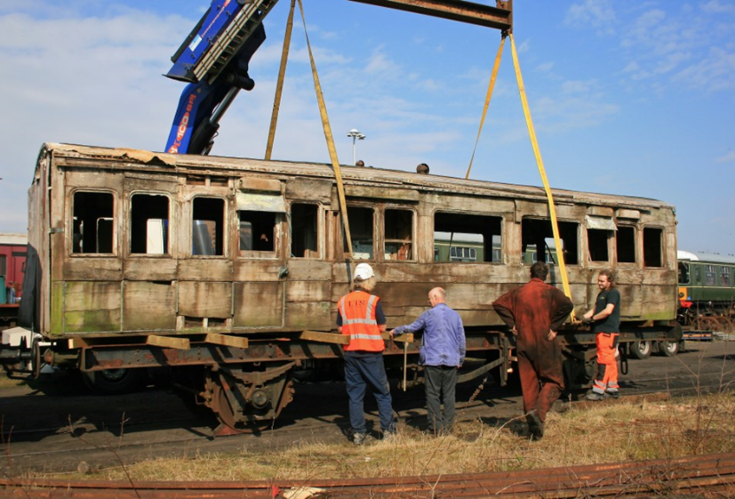**Restoration of Lancashire and Yorkshire Railway Family Saloon No. 12 – Built 1892**

|  |  |
| --- | --- |
| **Organisation Information** | **Contact Details** |
| East Lancashire Light Railway Company Ltd  Bolton Street Station  Bolton Street  Bury  BL9 0EY  [www.eastlancsrailway.org.uk](http://www.eastlancsrailway.org.uk)  Registered Charity Number 1186648  ELR is VAT registered  Sort code: 01-00-04  Account no: 01088580  Bank name: Nat West plc | Chair  Mike Kelly  [chair@eastlancsrailway.co.uk](mailto:chair@eastlancsrailway.co.uk) / 07766 137771  Secretary/General Manager  Tracey Parkinson  [tracey.parkinson@eastlancsrailway.co.uk](mailto:tracey.parkinson@eastlancsrailway.co.uk) / 07494 655130  Treasurer  David Layland – Finance Director (non-executive)  [finance@eastlancsrailway.co.uk](mailto:finance@eastlancsrailway.co.uk) / 07976 870831 |

1. **Project Details - What is the heritage asset for which you are seeking funding?**

We are seeking a grant of £17,000 to undertake the restoration of the Lancashire and Yorkshire Railway (LYR) Family Saloon No 12 – the only remaining carriage of its type from this once-thriving independent railway company. The LYR was formed in 1847 and operated for 75 years. It was probably the most intensively worked general carrier in the UK and, at its peak in 1920, it incorporated 601 route miles, 291 passenger stations, even more goods stations, 91 tunnels, 2,478 bridges and viaducts and 32 engine sheds. The LYR operated 1650 locomotives (of which only 468 were classed as passenger locomotives), 4360 carriages and 38,000 goods wagons. This was an immensely busy railway, the majority of its work being the transportation of goods across the network. It proudly termed itself ‘the Business Line’ to reflect its vital role transporting workers and goods to the mills, and coal from the pits. In 1922 the LYR amalgamated with the London North Western Railway for 1 year prior to the final grouping of the Big Four railway companies established in 1923. Despite LYR’s impressive credentials, very little survives today to evidence the scale of the network and the impact of the railway on industry and society across the North. Much of the railway infrastructure was demolished and only 21 carriages remain, with the majority in such poor condition that restoration is no longer viable. Consequently, the rich heritage of this railway is at considerable risk, with diminishing opportunities for the general public to learn about and understand its significant contribution to the UK’s industrial heritage.

Restoration of the Family Saloon therefore presents an exciting – and significant – opportunity to preserve a vital piece of industrial history and, for the first time, enable thousands of visitors annually

to connect with its heritage. It is the only example of such a vehicle from LYR’s stock of 4,360 carriages and was designed specifically for the transportation of a family. It was constructed at Newton Heath Works in East Manchester, the main carriage building facility for the Lancashire and Yorkshire Railway. Designed under the leadership of Frederick Attock, the works developed a standardised method of carriage construction which was revolutionary in the industry for its time. The doors and window frames were standard fits and created a distinctive style which continued until the end of the 19th century. In its latter years, the saloon was converted into a Directors’ Saloon and was used by the Directors of Newton Heath LYR Football Club – the same team which, in 1902, become Manchester United. There is every possibility that the Directors that led the way in making the world’s most famous football team were transported in this carriage.

The vehicle is wooden-bodied but on a steel underframe. The original underframe has long since been lost and the body is currently mounted on a British Railways Pipe Van underframe which is not an exact fit but has enabled the successful storage and movement of the vehicle whilst it awaits its fate. The body frame is sound and is capable of being lifted. The interior fixtures and fittings exist and are located in storage in Rochdale. It is currently stored outside and under tarpaulin at East Lancashire Railway’s Buckley Wells works – at continued risk of further deterioration due to weather or potential vandalism.

* *Why is it important to industrial heritage and history, what is its value to the local community and what do you propose to do with the grant?*

The LYR was a network of extraordinary local and national significance. It was the most densely-trafficked system in the British Isles with more locomotives per mile than any other company. It was the first mainline railway to introduce [electrification](https://en.wikipedia.org/wiki/Electrification) of some of its lines, and it also ran [steamboat](https://en.wikipedia.org/wiki/Steamboat) services across the [Irish Sea](https://en.wikipedia.org/wiki/Irish_Sea) and [North Sea](https://en.wikipedia.org/wiki/North_Sea), being a bigger shipowner than any other British railway company. Alongside this central role in the UK’s industrial heritage, it was at the heart of communities across the North, with 73,000 season ticket holders and c. 37,000 employees, linking towns and villages from coast to coast. Simply, the LYR drove a revolution in trade, travel and the daily lives of people across the North. However, this history is ebbing away and we must seize this opportunity to restore a distinctive and important carriage that shines a light onto this heritage.

The East Lancs Railways is ideally placed to undertake this restoration. Opened as a heritage railway in 1987, we welcome 200,000 visitors annually and are one of the busiest visitor attractions in the North West. Our affiliated Transport Museum, based in a Grade II-listed ex-railway warehouse from 1848, houses a collection of vintage vehicles including trains, buses, steam rollers and trams and provides hands-on exhibits to explain the development of transport in the North West. The museum and its events programme is specifically geared to families and school groups, recently hosting 120 primary school children for an International Women’s Day event to encourage interest in STEM subjects.

Crucially, the East Lancs Railway has a strong team of professional carriage and wagon restoration professionals who have been working and restoring vehicles for over 30 years and are now leading experts in the provision of rolling stock for safety critical duties.  This includes the Heritage Railway Association working group on Mark 1 vehicle restoration.  We also have refurbished several first class vehicles to form an exquisite dining train experience for our passengers.  Whilst these vehicles are beautiful on the inside they also deliver the highest standard of catering equipment possible for a train on the move, whilst retaining the historic nature of the vehicles.  We have a dedicated wood working expert and team of volunteers that look after the interior and exterior of wooden bodied vehicles and who have done contract work for other organisations, including LYR.

Of course, Bury was – itself – part of the LYR (from 1859) and saw huge growth and new prosperity through the industrial revolution and the proliferation of cotton mills. Today, the ELR is at the heart of the Bury community, with 800 local volunteers and a programme of much-loved year-round events such as Santa Specials and Dining Experiences. Restoring and displaying the Family Saloon within this warm, knowledgeable and supportive railway community feels like a fitting next chapter for this historic carriage. By working in collaboration with the LYR Trust – the owners of the carriage – we can pool our

knowledge and expertise and undertake a high-quality restoration project that brings this unique carriage back into operation, to be accessed and enjoyed by our local communities once more.

The Project

The restoration programme would take place over two years from September 2023. This would be a comprehensive scheme comprising work to the underframe to provide a suitable and adequate structure for the main timber body, the braking systems to ensure they are fail safe and meet with the standards required for passenger carrying vehicles, the timber body and replacement roof, panelling, doors and glass. The interior fixtures will also need to be overhauled or replaced prior to installation. This work will be undertaken by ELR’s professional carriage and wagon team who have extensive experience of restoring immensely fragile but historically significant vehicles. We anticipate that that the restoration would need a four person team working two days per week, over the two year restoration period.

Public engagement with this restoration, and the broader heritage of the carriage and railway, will commence in the earliest phases of the project. We plan to partner with two volunteer groups who will work on the restoration with ELR engineers throughout the project:

* a group of up to 20 Year 11 students from Hazelwood High School in Bury.

Hazelwood High School is in one of Bury’s most disadvantaged wards, with over half its pupils receiving the pupil premium, and more than 20% with English as a foreign language. We will work closely with school leaders to support the young people in developing new practical skills, increase their knowledge of local industrial heritage and open up routes into training and future careers in STEM.

* volunteers from The Big Fandango, a community suicide-prevention group based in Bury

Our volunteers, and those across the UK’s heritage railways, are predominantly male. With males accounting for three quarters of deaths from suicides each year, we are keen to work with community partners to provide training, build awareness and provide direct volunteering opportunities to support good mental health. Over the two year restoration, we plan to engage at least 20 new volunteers.

While some of the restoration work will necessarily take place in our sheds (e.g. welding, carriage wheelset overhaul, brake gear overhaul and the examination and preparation of the internal fittings) work to the body of the carriage will take place within the Transport Museum, enabling visitors, young people and school groups to see the process at first hand. Once complete, the coach will remain on display in Bury Transport Museum, with occasional excursions out along the railway.

* *What is the ownership of the asset for which you are seeking funding?*

The LYR Trust and the ELR have agreed a 10 year loan of the Family Saloon, with the ELR completing the work, insurance and upkeep. The ELR has aspirations to develop a strong collection of LYR vehicles and this has started to take shape with the loan of ‘Wren’ from the National Railway Museum at York to the Bury Transport Museum for a period of 3 years. The ELR and the Trust would consider longer term options for the vehicle to be on the ELR site after the 10 year period.

1. **Financial Information**

We seek a grant of £17,000 from the AIA to contribute to the total £30,000 cost of this carriage restoration. This sum would cover the cost of all wood needed to complete the project and all costs related to restoration of the seats. A full cost breakdown is provided below.

|  |  |
| --- | --- |
| **INCOME** | |
| **Costs** | **Amount** |
| **Restoration** | |
| East Lancashire Light Railway Co – confirmed in-kind support of 800 volunteer hours | £8,000 |
| Lancashire & Yorkshire Railway Trust –  forecast | £5,000 |
| Association for Industrial Archaeology – this application | £17,000 |
| **Total** | **£30,000** |
| **Public Engagement** | |
| East Lancashire Railway Co – confirmed investment from core budgets | £4,000 |
| Granada Foundation – application to be submitted in June 2023 | £3,500 |
| **Total** | **£7,500** |
| **GRAND TOTAL** | **£37,500** |

|  |  |
| --- | --- |
| **EXPENDITURE** | |
| **Costs** | **Amount** |
| **Restoration** | |
| Wood. Teak or teak alternative for the panelling and doors | £10,000 |
| Underframe welding, brake gear overhaul, brake blocks. | £5,000 |
| Other materials: paint, upholstery, overhaul of fittings for internal. Glass for the windows. Transfers for the internal and external livery. Roof repairs and recovering. | £5,000 |
| Seating (these will need to be made) | £7,000 |
| Contingency / Inflation | £3,000 |
| **Total** | **£30,000** |
| **Public / Volunteer Engagement** | |
| Museum Interpretation/Volunteer Project Management | £5,000 |
| Exhibition Materials to support public access to the restoration in the Transport Museum | £1,000 |
| Community launch event on completion of restoration | £1,000 |
| Marketing and PR to support public engagement | £500 |
| **Total** | **£7,500** |
| **GRAND TOTAL** | **£37,500** |

To enable this restoration to go ahead, we have secured verbal agreement from the LYR Trust of a £5,000 contribution, with associated paperwork in train. ELR will also commit to a minimum in-kind contribution of c. 800 volunteer hours over the two years (with a total value of £8,000 at minimum wage). To fund the public engagement element of the project, ELR will make an investment of £4,000 and we plan to make a £3,500 application to the Granada Foundation – a North West charity supporting community engagement with science, culture and heritage. Volunteers will research the structural integrity of the vehicle for weaknesses and splice new timbers in to support, repanel the side interior, and replace exterior panels. Doors, windows, latches and locks will need to be replaced and, finally, the roof will be replaced and made water-tight before the painting of the vehicle.

1. **Public Access**

Following completion of the restoration – much of which will have already been accessible to the public – the Family Saloon will remain on display in Bury Transport Museum, visited by over 2,000 young people each year. We have an ambitious development programme ahead for Bury Transport Museum, timed to coincide with the Railway’s 200th anniversary in 2025. The Family Saloon would form an important part of this and our plans to grow a programme of STEM activities for pre-school children, restoration skills training for 11-18 year olds and a new oral history project. The Museum is open from 10am to 4pm whenever public services are running on the railway (c. 120 days per year), with free admission for railway passengers and a nominal charge for non-railway passengers. The carriage will be accompanied by a display about its unique history and the vital role of LYR through the Industrial Revolution, and form part of the educational programme for school visits. The carriage will also be in use on the ELR approximately 3-4 times per year.

1. **Project Timetable**

We hope to begin restoration work in September 2023, following a period of planning from June 2023. The aim is for the vehicle to be completed by 2025 in time to celebrate 200 years of the creation of railways. Monthly work progress reports will be shared on social media and through the ELR channels.

The ELR’s Conservation Policy and Statement is attached, along with a schedule of work.